REQUEST FOR QUALIFICATIONS
CONCESSIONAIRE FOR LAKESIDE PARK PAVILION

CITY OF FOND DU LAC, WISCONSIN

Prepared By:

City of Fond du Lac
Purchasing
P.O. Box 150
160 South Macy Street
Fond du Lac, WI 54936-0150
Telephone: (920) 322-3470
Fax: (920) 322-3471
www.fdl.wi.gov

The City of Fond du Lac is requesting proposals for the operation of the concession stand in the Pavilion building (71 E Promen Drive), and a satellite location at the Playground at Lakeside Park in Fond du Lac, WI. The playground location will require the awardee to have a trailer from which to serve the concessions. The requirements of the City are outlined within this document. Proposals will be received until 4:00 PM January 28, 2021. Each proposal shall be submitted to the Purchasing Manager of the City at:
City of Fond du Lac
Attn: Purchasing
PO Box 150
Fond du Lac, WI 54936-0150

Or they may be submitted electronically to: jmusack@fdl.wi.gov.

Location:
  - The Lakeside Park Pavilion Concession Store is located at 71 Promen Drive in the City of Fond du Lac. There is also a satellite location at the playground on North Main Street, south of the crosswalk between the playground and the amusement rides.

Time of Operation:
  - The awardee will provide concessions at the Pavilion for the 2021 and 2022 summer seasons. The City is currently remodeling the Pavilion, with construction to be completed by June 1, 2021. The floorplan for the concessions area from the construction documents is included in this packet. The contract will be subject to an annual review of performance, audit of records, by the City, and negotiation of terms of the agreement.

Hours of Operation:
  - Memorial Day through Labor Day the minimum hours of operation will be:

Pavilion

Sunday | 11:00 a.m. to 6:00 p.m.
Monday | Closed
Tuesday | Closed
Wednesday | Closed
Thursday | Closed
Friday | Closed
Saturday | 11:00 a.m. to6:00 p.m.

Playground Satellite

Sunday | 11:00 a.m. to 6:00 p.m.
Monday | Closed
Tuesday | Closed
Wednesday | 2:00 p.m. to 6:00 p.m.
Thursday | 2:00 p.m. to 6:00 p.m.
Friday | 2:00 p.m. to 6:00 p.m.
Saturday | 11:00 a.m. to 6:00 p.m.

Hours and days of operation will vary before Memorial Day and after Labor Day. Operating hours shall be posted. Additional hours may be offered at the discretion of the Concessionaire; and approved by the Parks Superintendent.

SPECIFICATIONS:

- Payment – The Concessionaire shall pay the City 10% of all gross sales each year including all catering events.

- Schedule of Payment –Payments shall be made in two installments each year. The first payment will be due on or before July 31 and second payment due on or before October 31. Concessionaire will provide a listing by date, of gross sales, along with payment.

- Inspection of Records. The Concessionaire shall keep accurate records of sales by means of cash register tapes, and shall also keep accurate records of all purchases, and inventories. All records shall be available for inspection by the City at any reasonable time. A complete annual detailed operating statement shall be provided to the City for each concession on or before December 31st each year.

- Scope of Concession.
  - All foods normally prepared in restaurants may be prepared in the pavilion concession store and made available to the public, either single short orders, or catered meals to groups with park reservations. In addition, popcorn, pre-packaged food items such as candy bars, ice cream bars, canned and dispensed soft drinks and picnic supplies may also be sold.

  - All services in the "Scope of Concession" shall be provided to the general public without discrimination as to race, creed, color or sexual orientation, disability, religion, national origin, marital status, family status, status as a victim of domestic abuse, sexual assault, or stalking, lawful source of income, age, or ancestry.

  - All concessions, foods and beverages shall be stored and dispensed only in a manner approved by the Fond du Lac County Health Department.

  - There shall be a responsible person, who must be at least 18 years of age, in charge of and on the premises during open hours of the store.

  - Concessionaire willll have exclusive use of the Lakeside Park Pavilion Concession Store pursuant to the terms of this Agreement. However, this Agreement is not intended to grant Concessionaire an exclusive franchise in Lakeside Park. The City specifically reserves the right during the term of this Agreement to grant additional franchises to, enter into contracts with, or otherwise permit other vendors to provide goods and services in Lakeside Park at any location deemed appropriate by the City. The City shall not be held responsible or liable to Concessionaire for any alleged damages or loss of business that may be caused by permitting other vendors to operate in Lakeside Park.

- Signs, Alterations, Repairs or Improvements. Concessionaire shall not make any alterations, repairs or improvements to the concession store or to the area surrounding without obtaining the prior written consent of the Park Superintendent. Request to make any alterations, repairs or improvements shall be made at the expense of Concessionaire and shall become property of the City. The Concessionaire may, after obtaining the necessary sign and other permits from the City, advertise its name and services on the pavilion and trailer at the satellite site, but not in other park locations. The City may place the name of the Concessionaire on the City website and Lakeside Park maps if requested. Portable self-supporting signs may be used for informational purposes and kept inside the building when the concession stand is closed.

- Maintenance of Concession Store Area. Concessionaire shall be responsible for the reasonable and proper care of the concession portion of the Pavilion and shall repair, or cause to be repaired, any damages to City property caused by himself, his employees, agents, guests or patrons. The Concessionaire shall keep and maintain the concession store and exterior service areas in a clean and sanitary condition, and shall comply with the rules and regulations of the City Inspection Department.

- Utilities. Water, gas and electric services will be provided by the City of Fond du Lac for the concession store and electricity only for any additional stands. Concessionaire shall use the provided utilities only for running concession stores and will be a responsible steward of same.

- Compliance with Laws. Concessionaire shall observe and comply with all laws, statutes, ordinances, rules and regulations of the United States Government, the State of Wisconsin, and the City and County of Fond du Lac, or any department or agency of the above. Concessionaire shall obtain all necessary licenses and permits, including soda and Class A beer license if applicable.

- Equipment. Concessionaire will have use of the concession area of the pavilion. This 325 sf area includes a sink, counters, range hood with fire protection, fire suppression system, and 156 sf storeroom. The City agrees that the Concessionaire’s inventory and equipment are his, alone, to use under the terms of this agreement. The City agrees the Concessionaire may store his inventory and equipment in the Park Pavilion. Both parties will take all reasonable steps to protect and safeguard the Concessionaire’s inventory and equipment.

- Destruction of Premises. If during the term of this agreement, the premises are destroyed or damaged by Acts of God or other catastrophe so that the same is unfit for occupancy or use, the rental shall abate, if or until such time as the premises shall have been duly repaired and restored by the City, whereupon the lessee at his option may terminate this lease or continue thereunder pursuant to the terms and conditions of this agreement. A pro-rated portion of any rental prepaid prior to such destruction or damage shall be refunded for the period Concessionaire was not allowed the use of the premises.

- Subletting and Assignment. Concessionaire shall not sublet the whole or any part of the premises, nor assign or mortgage the concession agreement or any or all of its rights hereunder without the prior written consent of the City Manager.

- Indemnity. Concessionaire shall indemnify, save, and hold harmless the City and all of its officers, agents and employees, from any and all claims for losses, injuries, damages and liability to persons or property occasioned wholly or in part by the acts or omissions of Concessionaire, his agents, officers, employees, guests, patrons, or any person or persons admitted to said premises while said premises are used by or under the control of Concessionaire.

- Insurance. Concessionaire shall purchase and maintain the following insurance during the term of this agreement:
  - Commercial General Liability coverage, together with excess or umbrella liability policies in an amount not less than $1,000,000 for injury to one person in one accident, and $2,000,000 for injury to more than one person in one accident.
  - Property damage insurance in an amount not less than $1,000,000.
  - Worker’s Compensation insurance to meet Wisconsin Statutory requirements, and Employers Liability insurance with sufficient limits to meet underlying excess or umbrella insurance requirements.
  - This coverage shall also include all vehicles utilized by the Concessionaire, whether owned, non-owned or hired by him.
  - Property insurance in an amount equal to the value of the contents belonging to the Concessionaire.
  - The stated limits above can be obtained through individual policies or in conjunction with an umbrella policy to arrive at the total limits requested.
  - A certificate of insurance shall be filed with the City as proof of such insurance, endorsing the City of Fond du Lac as an additional insured. All insurance premiums shall be the obligation of and shall be paid by the Concessionaire.

- Breach of Contract. In the event of any breach of any of the terms or provisions of this agreement, the City shall have, in addition to any other recourse, the right to terminate this agreement, to enter and obtain possession of the entire premises, to remove and exclude any and all persons from the premises and to remove and exclude all property of the Concessionaire therefrom, all without service of notice or resort to legal process and without any legal liability on its part.

- Inspection by City. The City shall have the right to make inspections at any reasonable time to insure compliance with this agreement.

- Provision for Mail Service. The Concessionaire shall provide all vendors, suppliers, licensing or governmental agencies, or anyone involved in the business operation of the pavilion concession store with a business mailing address. All advertising shall also include such business mailing address. Mail service will not be provided by the Park Office.

- Surrender of Premises upon Termination. Upon the termination of this agreement, Concessionaire shall peaceably surrender and deliver up possession to the City of the demised premises, including all improvements or additions thereto, in good order and condition, reasonable wear and tear excepted. The entire facility shall be thoroughly cleaned, to the satisfaction of the Superintendent of Parks. This clean-up shall be accomplished within fourteen (14) days following the termination date of the agreement to operate the concession store.

- Additional Information:
  - An unfurnished outdoor seating area and delivery access are available for use by the Concessionaire.
  - One satellite site with a concrete pad and electric service will be available for the Concessionaire’s use near the playground on N. Main St. The Concessionaire is responsible to provide trailer or equipment to use this site. This trailer shall be removed over the winter months. Concessionaire may have one (1) additional stand on Memorial Day weekend, July 4th, and Labor Day weekend. Placement of these stands shall be approved by the Park Superintendent.
  - The pavilion site may operate during Walleye Weekend, but the satellite may not due to conflicts with other venders.
  - The Concessionaire may not operate any mobile operations (i.e. ice cream trucks) in the parks without permission from the Park Superintendent regarding the location and schedule of such sales. The Concessionaire must also comply with all provisions set forth in Chapter 356, Food and Food-Handling establishments.
  - Any building upgrades needed for Concessionaire operations shall be at its own expense.
  - Further information, if needed, may be obtained by contacting the Park Superintendent at 920-322-3592. A copy of the eventual contract is included at the end of this document for your review.

Selection Criteria:
The objective of this RFQ is to provide dependable and consistent concession services at Lakeside Park. The successful proposer will be selected after evaluation of the RFQ elements:
- Experience/References
- Product Offering

No contract shall be awarded to any person, firm, joint venture, or corporation that is in arrears or is in default to the City upon any debt or contract or that is a defaulter as surety or otherwise upon any obligation to the City.

The City reserves the right to:
- Reject any or all proposals, and to waive minor irregularities in any proposal
- Request clarification of information submitted and to request additional information of any proposer
- Screen vendors for background checks and credit checks
- Award contract based on what is in the best interests of the City of Fond du Lac and its citizens
- Award contract to next most qualified contractor if the selected vendor does not execute an agreement within 15 days after the award of the proposal.
- Request additional information from each applicant and to request additional oral interviews

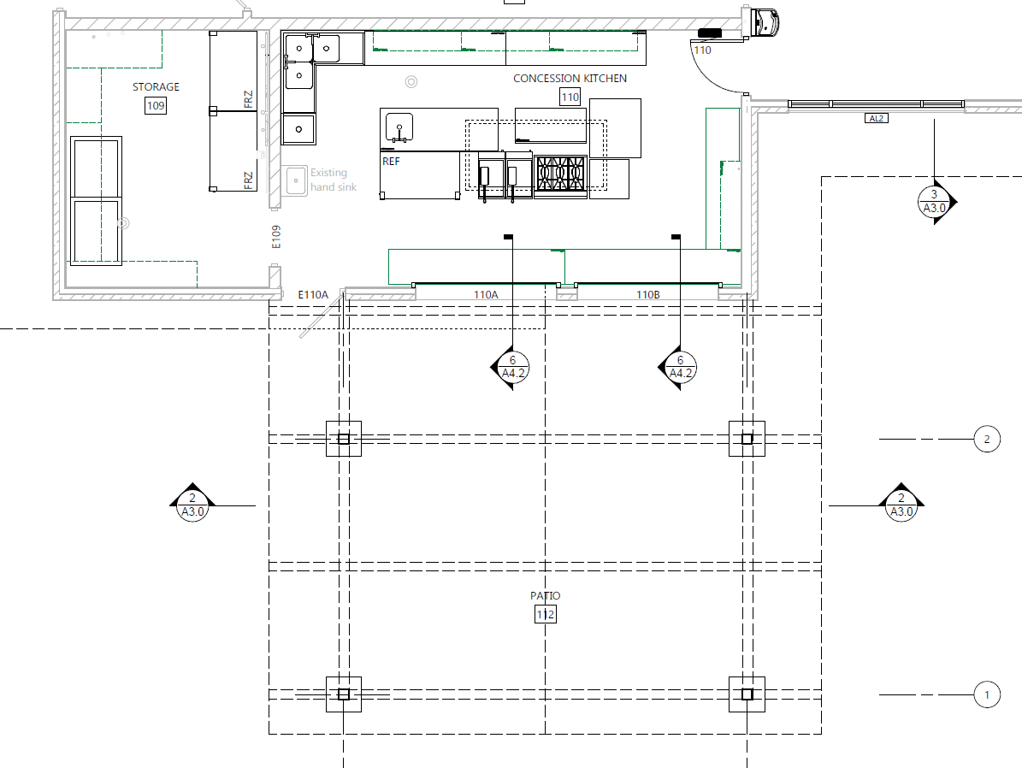

2021-2022 Lakeside Park Pavilion Concessionaire Proposal Form

Organization Name:_____________________________________________________________________

Organization Address:___________________________________________________________________

Organization Structure:
( ) Sole Proprietorship ( ) Partnership ( ) Joint Venture ( ) Corporation ( ) Non-profit

Contact Name:_________________________________________________________________________

Contact Address:_______________________________________________________________________

Contact Email:_________________________________________________________________________

Contact Telephone:_____________________________________________________________________

Complete the following questions. Attach additional pages if necessary.
- Describe your background, ability, and experience in providing concessions in a park or other public/private setting. Include number of years of food and beverage concession experience, locations of previous experience, and any other pertinent information. If services were provided under a previous business name, please provide.

- Describe your process for screening employees and or volunteers for criminal history to ensure that persons with extensive criminal history or crimes of violence against others will not be employed.

- List a minimum of three references related to recent experience pertaining to concessions:

  - Reference 1
    - Business Name:
    - Contact Person:
    - Phone Number:
    - Other info:

  - Reference 2
    - Business Name:
    - Contact Person:
    - Phone Number:
    - Other info:

  - Reference 3
    - Business Name:
    - Contact Person:
    - Phone Number:
    - Other info:

- Have you or your business ever been involved in any litigation? If so please explain.

- Are you prepared to accept cash, credit, and debit payments? If not list what you can accept.

- Explain the process you will use to verify sales.

- List the proposed food and drink products to be sold at each of the concession areas. Provide proposed prices or criteria by which future pricing will be determined.

CONTRACT

CONCESSIONAIRE FOR LAKESIDE PARK PAVILION

THIS AGREEMENT, made and entered into this day of , 2021, by and between the CITY OF FOND DU LAC, a Wisconsin municipal corporation, hereinafter called “City” and , hereafter called “Concessionaire”.

W I T N E S S E T H:

WHEREAS, City is the owner of premises commonly known as “LAKESIDE PARK CONCESSION STORE” and has the power to grant rights and privileges with respect thereto; and

WHEREAS, Concessionaire is desirous of obtaining certain rights and privileges upon terms and conditions hereinafter provided in City specifications to be considered part of this contract.

NOW, THEREFORE, in consideration of the premises, covenants, terms and conditions hereinafter contained, the parties mutually agree as follows:

- Location. The Lakeside Park Concession Store is located at 71 Promen Drive in the City of Fond du Lac.
- Terms of Agreement. The term of this agreement shall be for the 2021 and 2022 seasons. This contract may be renewed on an annual basis upon the mutual consent of the parties.
- Schedule of Payment. 10% of gross sales, including all catering events, shall be made to the City according to the schedule provided in the City Specifications. A full operating statement shall be provided by the Concessionaire for review by the City on or before December 31st for each season.
- Time of Operation. The Concessionaire agrees to open these facilities on the dates and times provided in the City Specifications.
- City Specifications. The City Specifications attached hereto are hereby incorporated by reference and shall be considered a part of this contract as if set forth herein.
- Breach of Contract. In the event of any breach of any of the terms or provisions of this agreement, the City shall have, in addition to any other recourse, the right to terminate this agreement, to enter and obtain possession of the entire premises, to remove and exclude any and all persons from the premises and to remove and exclude all property of the Concessionaire therefrom, all without service of notice or resort to legal process and without any legal liability on its part.
- Government Immunity. The City of Fond du Lac is a governmental entity entitled to governmental immunity under law, including Section 893.80, Wis. Stats. Nothing contained herein shall waive the rights and immunities to which each party may be entitled under law, including all of the immunities, limitations and defenses under Section 893.80, Wis. Stats., or any subsequent amendments thereof, any federal law, common law or other applicable laws.
- Notices. Notice or other communication given pursuant to this Agreement shall be in writing and shall be effective either when delivered personally to the party for whom intended or five days following deposit into the United States Mail (certified mail, return receipt requested or first class postage prepaid) addressed to such party at the address set forth below:

To the City: City Clerk
City of Fond du Lac
160 South Macy Street
Fond du Lac, WI 54935-0150

To Concessionaire ADD HERE

- Governing Law. The Laws of the State of Wisconsin shall govern this Agreement.

IN WITNESS WHEREOF, the parties hereto have executed the foregoing Agreement the day and year first written above.

CONTRACTOR

(Contractor Signature)

Name and Title

Name and Title

CITY OF FOND DU LAC

City Manager

Director of Administration City Clerk

Approved as to form:

City Attorney Date

