**City of Fond du Lac Terrace Tree Planting Guidelines**

Trees in a community, whether they are located in private yards, along city streets, or in a city park, can benefit the urban environment in which we live, work, and play.

**Trees**

* Reduce storm water runoff
* Lower summer air temperature
* Reduce air pollution
* Reduce heating and cooling
* Reduce atmospheric carbon dioxide
* Enhance property values
* Provide wildlife habitat
* Improve health and well being
* Improve learning and concentration
* Provide aesthetic benefits

Fond du Lac street trees provide millions of dollars of benefits each year to the community. Therefore, it is important to maximize these benefits by planting trees in the proper location, planting the proper species for the site, and planting trees at the proper depth. Planting trees properly will help trees grow to their full potential and maximize the benefits they provide. Enclosed are some guidelines the City recommends to help property owners who want to plant trees on the public terrace area (area between sidewalk and curb).

**Resident Plantings**: Residents or property owners who wish to plant trees at their own expense in the city right-of-way shall fill out a free **Tree Planting Permit** (Ordinance 8.12) (Appendix F) to the City Arborist prior to beginning work. Species should be chosen from the recommended tree planting lists contained in Appendixes B, C, and D. The City Arborist will review all permits with emphasis on planting the “right tree in the right place”.

**Unimproved Streets**: Trees shall not be planted in the terrace on unimproved streets or where no curb and gutter exists without approval from the City Arborist and City Engineer.

**Other terrace tree planting options for property owners**

A property owner may get a tree planted on the terrace through the City’s cost share planting program. The program is a 50/50 cost share planting program between the City and the property owner. The City has a list of trees that are planted by the city’s contractor. The costs to the property owner can range from $50-$120 depending on species. Contact the City Arborist for current prices, species selection, and details of the program at 920.322.3594 or email at bweed@fdl.wi.gov.

**Other ways trees are planted on terrace**

Trees are planted after street reconstruction project. There is normally one year delayed after the year of construction so the grass can get established and the project is total complete before trees are planted. These trees are funded by the project and are selected by the City Arborist to help diversify the tree population and plant the right tree in the right location. Should a tree fail, a replacement will be planted as long as replacement tree funding is available.

Trees are planted in newly developed areas of the city. These trees are planted when 50% of the houses have been built. This is done to alleviate unnecessary moving of trees when driveway approaches are installed. These trees are funded as part of the development and are selected by the City Arborist. Should a tree fail, a replacement will be planted as long as replacement tree funding is available.

**Ways trees are planted in our parks system**

Trees normally are planted as part of the City’s Tree Planting Program. Trees can also be planted as donations. Please contact the Parks and Forestry Division 920.322.3590, if you wish have a tree planted in the City park system.

**Tree Planting Standards**

**Size**: All trees planted along the terraces and within public spaces must be of sufficient size to absorb the abuse and conditions common to trees planted in urban areas. The minimum allowable size for shade trees is 1.5” caliper and 1.5” caliper for ornamental trees, however larger sizes may be required to ensure survival for specific situations. Tree caliper shall be measured six inches above the ground to the nearest ¼”.

**Condition**: Unless otherwise specified, all trees shall conform to the American Nursery and Landscape Association’s *American Standard for Nursery Stock,* (Z60.1- 2004). Each tree chosen for planting shall be a high-quality, healthy tree with evidence of vigorous growth during the previous year. All trees shall have a comparatively straight, single trunk, well developed leaders and crown, and the roots shall not only be characteristic of the species, cultivar or variety, but also exhibit evidence of proper nursery pruning practices. Ornamental trees may be multiple- stemmed if they can be pruned for adequate clearance. At the time of planting, all trees must have a full healthy crown, be free of mechanical injuries and display no other objectionable features that will affect the future form, health, and beauty of the tree.

**Planting Methods**: Proper planting methods (Figure 1) are critical to ensuring a high level of transplanting success by encouraging proper root growth and reducing transplant shock.

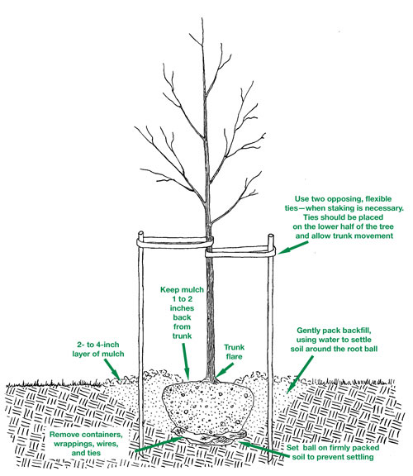

**Figure 1 Proper Tree Planting Methods**

A large planting hole 12 inches larger than the diameter of the root ball shall be used leaving a pedestal of soil in the center of the hole on which to rest the tree. The root/trunk flare should at or slightly above the finished grade. When using balled and burlapped planting stock, remove the wire, burlap and twine from at least the top one half of the root ball, thus minimizing disturbance to ensure the root ball’s integrity. If necessary, use a sharp hand pruner to remove any damaged roots as needed. Whenever possible, backfill the hole with native soil and do not add amendments such as compost, peat moss, or stone to “improve” the soil. Water the tree generously to eliminate large air pockets and firm the soil around the tree’s roots.

**Location:** All street trees shall be planted midway between the curb and sidewalk (or where the sidewalk would be if there is no sidewalk), unless in the opinion of the City Arborist, there is sufficient reason to plant the trees off-center.

To allow for maintenance, minimize infrastructure damage and promote safety, trees shall be planted using the following guidelines. Exceptions to these guidelines may be made by the City Arborist when circumstances warrant and public safety is not threatened.

1. 50’ from an approach corner   
2. 35’ from a non-approach corner   
3. 20’ from a street light   
4. 10’ from a driveway, utility pole, or fire hydrant   
5. 10’ from a gas valve, water valve, or carriage walk   
6. 3’ from the curb

**Vision Triangle**: No trees (or shrubs greater than 36” in height) shall be planted in the Vision Triangle as specified in section 11.04 of Fond du Lac Municipal Code. The Vision Triangle is determined by measuring 20’ along each sidewalk from the inside corner and connecting the points to form a triangle. See Appendix A for a diagram of the Vision Triangle Ordinance.

**Spacing**: Future maintenance problems can be minimized by careful and thoughtful placement of trees. Spacing of trees is a function of local site conditions, the species or cultivar used, and their, mature height, spread and form.

**Recommended Street Trees**: Appendixes B, C and D contain the lists of tree species approved for planting in the City based upon their mature size. The arborist shall review annually the trees listed in these appendices to determine whether any species, cultivars or varieties should be added or removed from the lists.   
Only small-growing trees (Appendix B) shall be planted under overhead secondary or primary electrical distribution lines. Trees planted to the side of power lines shall be carefully selected for mature habit to minimize future conflicts.

**Undesirable Street Trees**: Unacceptable species or their varieties as listed in Appendix E shall not be planted on City property, except in special locations where, because of characteristics of adaptability or landscape effect, they can be used advantageously. Their lack of suitability is based upon objectionable growth habits, fruiting habits, form, susceptibility to serious diseases, propensity to incur storm damage, and other limitations. The limitations listed for each tree or species are the more serious problems encountered locally.

**Maintenance of Newly Planted Trees**

**General**: Newly planted trees, shrubs and other plants require special maintenance for one or two growing seasons following planting. All maintenance practices shall follow approved arboricultural standards.

**Watering**: Since up to 95% of the tree’s roots were cut when the tree was dug in the nursery, regular watering is important to aid in the development of a strong new root system. Trees need the equivalent of about one inch of rain every week. When the soil is dry four inches below the soil surface, it is time to water.

**Mulching**: A layer of mulch around the newly planted tree is beneficial. It helps reduce competition from grass and weeds, retains soil moisture, improves soil fertility and structure and protects the trunk from damage caused by mowers and string trimmers. A 3-4” layer of mulch shall be placed at an even depth around the tree. Mulch shall be pulled away from the trunk so as not to be touching the trunk as this promotes fungal diseases and encourages rodents to girdle the bark at the base of the tree. Shredded bark or wood chips are recommended materials, but be sure the material is seasoned or composted before using. The use of stone or other inorganic material is discouraged and generally not recommended.

**Pruning**: No pruning should occur at the time of planting except to remove dead or broken branches. Unnecessary pruning at this time may reduce the amount of stored energy the plant holds and may stress the tree. A pruning schedule may be started 3-4 years after planting. The city will prune these trees as needed or as part of its pruning cycle.

**Staking**: Trees will be stakes at time of planting, if needed. All staking material will be removed within two years by the city unless deemed necessary for continued stability.

**Wrapping**: Studies have found that trunk wrap often does more harm than good. However, wrap may be seasonally used to protect young trees from sunscald or cracking, but should be removed every spring to prevent long-term damage.

**Digger’s Hotline and Local Utilities**

Digger’s Hotline (800-242-8511 or 811) and all appropriate local utility companies must be notified prior to any underground excavation, including but not limited to: tree planting, stump removal and root repair. Three business days are customarily required as sufficient notice for the processing of locates. Proper marking of excavation sites prior to calling ensures that no resident, employee or utility are at risk from damage to unmarked utilities. Work within 18” of any underground utility requires hand digging to expose the facility and prevent unnecessary damage to utilities. Private utilities (i.e. irrigation, pet fences, private lighting etc.) located within the public right-of-way shall be marked by the adjacent property owner at their expense. The City cannot assume responsibility for any damage as a result of unmarked private utilities in the right of way.

**APPENDIX A - VISION TRIANGLE DIAGRAM**

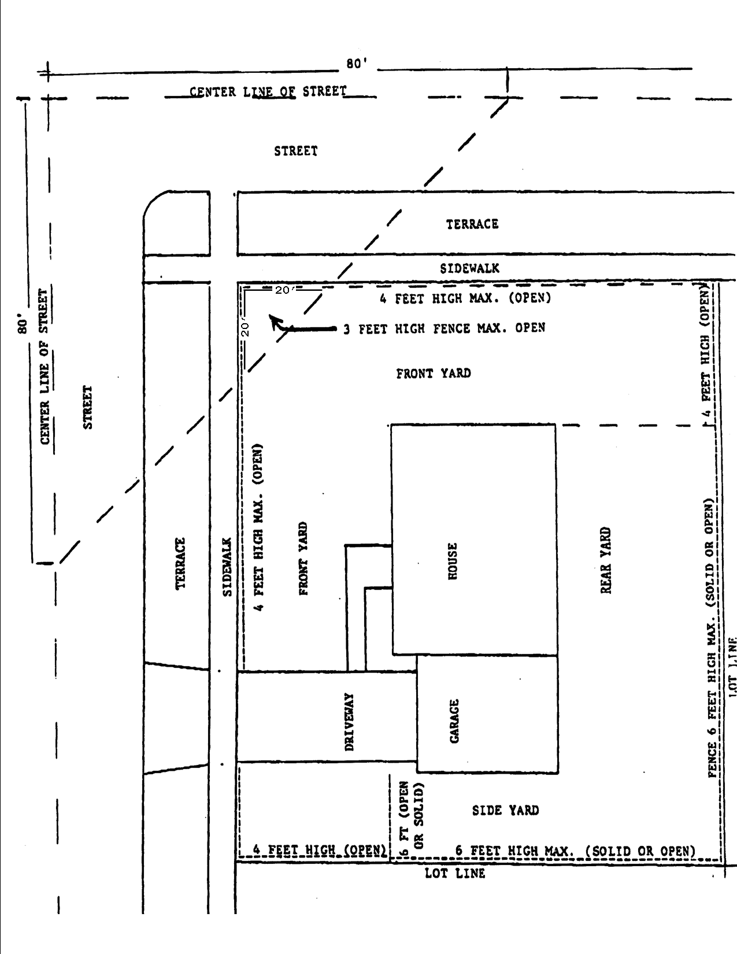

**APPENDIX B - SMALL TREE PLANTING LIST**

(Up to 30’ in height)

|  |  |  |
| --- | --- | --- |
| SCIENTIFIC NAME | COMMON NAME | CULTIVARS |

|  |  |  |
| --- | --- | --- |
| ACER GINNALA | AMUR MAPLE TREE FORM |  |
| ACER TATARICUM | TATARIAN MAPLE |  |
| AMELIANCHIER CANADENSIS | SERVICEBERRY TREE FORM | AUTUMN BRILLIANCE |
| MAACKIA AMURENSIS  Cultivars that bear fruit not recommended for terraces under 15 feet | FLOWWERING CRABAPPLE | GOLDEN RAINDROPS  INDIAN SUMMER  PARIRIFIRE  RED BARRON  RED JEWEL  SENTINEL  SNOWDRIFT  SPRINGS SNOW  SUGAR TYME  Other cultivars/varieties upon approval |
| SYRINGA PENKINENSIS | PEKIN TREE LILAC | CHINA SNOW |
| SYRINGA RETICULATAQ | JAPANESE TREE LILAC | IVORY SILK |

This selection of species that could be planted is not limited to this list. Contact the City Arborist if you consider planting any species not listed on this list.

**APPENDIX C - MEDIUM TREES PLANTING LIST**

(30 to 45’ in height)

SPACING: 35’ minimum

TERRACE WIDTH: 6’ minimum

|  |  |  |
| --- | --- | --- |
| SCIENTIFIC NAME | COMMON NAME | CULTIVARS |

|  |  |  |
| --- | --- | --- |
| ACER PLANTANOIDES | COLUMNAR NORWAY MAPLE | COLUMNAR |
| ACER TRUNCATIM X PLANTANOIDES | SHANGTUN MAPLE | PACIFIC SUNSET  NORWEGIAN SUNSET |
| CERCIDIPHYLLUM JAPONICUM | KATASURATREE |  |
| CORYLUS COLURNA | TURKISH FILBERT |  |
| OSTRYA VIRGINIANA | AMERICAN HOPHORNBEAM OR IRONWOOD |  |
| PHELLODENDRON AMURENSE | AMUR CORKTREE | MACHO  SHADEMASTER |
| PYRUS CALLERYANA | CALLERY PEAR | AUTUMN BLAZE  CLEVELAN SELECT OR CHANTICLEER |
| SORBUS ALNIFOLIA | KOREAN MOUNTAIN ASH |  |

This selection of species that could be planted is not limited to this list. Contact the City Arborist if you consider planting any species not listed on this list.

**APPENDIX D - LARGE TREE PLANTING LIST**

(Over 50’ in height)

Spacing: 40’ minimum

TERRACE WIDTH: 8’ minimum

|  |  |  |
| --- | --- | --- |
| SCIENTIFIC NAME | COMMON NAME | CULTIVARS |

|  |  |  |
| --- | --- | --- |
| ACER X FREEMANII | FREEMAN MAPLE | AUTUMN BLAZ  CELEBRATION  MARMO |
| ACER PLATANOIDES  Limit use of this species is encouraged due to over planting | NORWAY MAPLE | CLEVELAND  DEBORAH  EMERALD QUEEN  FAIRVIEW  ROYAL RED  SUPERFORM |
| ACER SACCHARUM | SUGAR MAPLE | GREEN MOUNTAIN-LEGACY |
| AESCULUS HIPPOCASTANUM | HORESCHESTNUT | BOHMANNII |
| CELTIS OCCIDENTALIS | COMMON HACKBERRY | PRAIRIE PRIDE  WINDY CITY |
| EUCOMMIA ULMOIDES | HARDY RUBBER TREE |  |
| GINKGO BILOBA (MALE) | GINKGO OR MAIDENHAIR TREE | AUTUMN GOLD  MAGYAR  PRINCETON SENTY |
| GLEDITSIA TRICANTHOS | HONEYLOCUST | IMPERIAL  SHADEMASTER  SKYLINE  SUNBURST |
| GYMNOCLADUS DIOICUS | KENTUCKY COFFEE TREE | ESPRESSO  PRAIRIE TITAN |
| LIRIODENDRON TULIPFERA | TULIPTREE |  |
| QUERCUS BICOLOR | SWAMP WHITE OAK |  |
| QUERCUS MACROCARPA | BUR OAK |  |
| QUERCUS ROBUR | ENGLISH OAK | SKYMASTER |
| TILIA AMERICANA | AMERICAN LINDEN | REDMOND  BOULEVARD |
| TILIA CORDATA | LITTLELEAF LINDEN | CHANCELLOR  GLENLEVEN  GREENSPIRE  PRESTIGE  BAILEY |
| TILIA TOMENTOSA | SILVER LINDEN | STERLING |
| TILIA X EUCHLORA | CHIMEAN LINDEN |  |
| ULMUS SPP. | ELM HYBRIDS | ACCOLADE  HOMESTEAD  REGAL  NEW HORIZON  PROSPECTOR  TRIUMPH |
| ULMUS AMERICANA | NATIVE VARIETIES | PRINCETON  VALLEY FORGE |

This selection of species that could be planted is not limited to this list. Contact the City Arborist if you consider planting any species not listed on this list.

**APPENDIX E - UNDESIRABLE SPECIES**

|  |  |  |
| --- | --- | --- |
| SCIENTIFIC NAMES | COMMON NAME | PROBLEM(S) OR LIMITATION(S) |

|  |  |  |
| --- | --- | --- |
| ABIES SPP. | FIR | FORM – VISIBILITY HAZARD |
| ACER NEGUNDO | BOXELDER | WEAK WOODED, FEMALE ATTRACTS THE BOXELDER BUG |
| ACER RUBRUM | RED MAPLE | MANGANESE/IRON CHLOROSIS |
| ACER SACCHARIUM | SILVER MAPLE | WEAK WOOD, SUSUCEPTIBLE TO STORM DAMAGE, AGGRESSIVE ROOT SYSTEM |
| BETULA SPP. | BIRCH | ENVIRONMENTAL STRESS, BORERS |
| BETULA NIGRA | RIVER BIRCH | LITTERING FRUIT |
| CARYA SPP. | HICKORY | LITTERING FRUIT |
| CATALPA SPP. | CATALPA | LITTERING FRUIT |
| FAGUS SPP. | BEECH | LITTERING FRUIT |
| FRAXINUS SPP. | GREEN ASH, WHITE ASH, BLACK ASH, RED ASH | FLOWERING GALL PROBLEM, SUSCEPTIBLE TO EMERALD ASH BORERE |
| GINKGO BILOBA (FEMALE) | GINKO OR MAIDENHAIR TREE | MALODOROUS FRUIT |
| JUGLAN SPP. | WALNUT | LITTERING FRUIT |
| MALUS SPP. | COMMON APPLE | LITTERING FRUIT |
| MORUS SPP. | MULBERRY | LITTERING FRUIT |
| PICEA SPP. | SPRUCE | FORM – VISIBILITY HAZARD |
| PINUS SPP. | PINE | FORM – VISIBILITY HAZARD |
| POPULUS SPP. | POPLAR, COTTONWOOD | ROOTS BLOCK SEWERS, WEAK WOODED, COTTON TYPE SEEDS |
| PRUNUS SPP. | CHERRY OR PLUME | LITTERING FRUIT, DISEASE PRONE |
| PYRUS COMMUNIS | COMMON PEAR | LITTERING FRUIT |
| QUERCUS PALUSTRIS | PIN OAK | IRON CLHOROSIS |
| ROBINA SPP. | BLACK LOCUST | SHALLOW ROOTED, BORERS |
| SALIX SPP. | WILLOW | SHALLOW ROOTED, WEAK-WOOD |
| SORBUS AMERICANA | MOUNTAIN ASH | MESSY FRUIT, SUNSCALD PROBLEMS, INSECT BORERS |
| THUJA SPP. | ARBORVITAE | WEAK-WOODDED, STORM DAMAGE, FORM VISIBILITY HAZARD |
| ULMUS PUMILA | SIBERIAN ELM | WEAK-WOODED |
| ULMUS FRONTIER | FRONTIER ELM | HARDINESS |

**APPENDIX F – PLANTING PERMIT**

City of Fond du Lac Terrace Tree Planting Permit (Ordinance 8.12)

Street Address:

Number and Location of tree(s) (attached blueprint or sketch if possible):

Work to done by:

Tree species to be planted (include Genus, Species, and cultivar):

Size of tree(s) in inches (caliper or diameter measured 6” above top of root system):

If permit grant, it is understood that the applicant for this permit is responsible for the proper cleanup. It is further agreed that the City of Fond du Lac shall not be held liable in any manner for personal injury or property damage occurring as a result of the applicant’s failure to perform the work on accordance with this permit. The city may repair such damage and charge the cost to the applicant. Any contractor performing the planting shall provide proof of insurance before permit is approved. Applicant must comply with all applicable arboricultural specifications and standards unless waived or modified in writing by city arborist.

Date:     , 20      Signed:

Address:      Phone:

**BEFORE YOU DIG, CALL DIGGERS HOTLINE 1-800-242-8511**

**Returned filled out permit form to: City Arborist**

**530 Doty St**

**Fond du Lac, WI 54935 or email: bweed@fdl.wi.gov**

**This section to be filled out by City Arborist**

Permit approved:      Permit denied:      Reason for denial:

Location marked by white paint on curb: yes  no  other       Site number

Permit issued:     , 20      Permit expires:     , 20

City Arborist:      Permit #