MAIL-IN SLIP RENEWAL PROCESS

- Sign and return both copies of the enclosed Municipal Boat Slip Permit.

- Enclose your check payable to City of Fond du Lac

- Fill out and return enclosed Municipal Boast Slip Information Sheet

- Enclose required documents; Copy of title, proof of insurance, trailer information if applicable and proof of residency

- Enclose a stamped, self-addressed envelope (if you would like a receipt).

- Mail all documents and payment to:
CITY OF FOND DU LAC
ATTENTION: CITY CLERK
P.O. BOX 150
FOND DU LAC, WI 54936-0150

- Credit cards are accepted online or in person only.

If there is any part of this mail-in rental process that you do not understand, please call the City Clerk’s Office at 920-322-3430.

The City is not responsible for incomplete information, incorrect payment of boat slip fees (including tax), or for misdirected or late mail which is not received by the renewal deadline.

Do not mail your original certificate of title with your mail-in renewal.

IN PERSON RENEWAL PROCESS

- Bring signed and completed documents, i.e. Municipal Boat Slip Permits, Municipal Boat Slip Information Sheet, copies of title and registration, proof of insurance and proof of residency to the City Clerk’s Office:
CITY-COUTY GOVERNMENT CENTER
160 SOUTH MACY STREET
FOND DU LAC, WI
HOURS: 7:45 am – 4:30 pm, MONDAY THROUGH FRIDAY
- Cash, Check, or Credit Card (Visa, MC, Discover) is accepted in person for boat slip payment, a receipt will be provided.

ONLINE RENEWAL PROCESS
Registration Information
NOTE: If you choose to make an online payment please be aware that SLIP RENEWALS WILL NOT BE PROCESSED UNTIL ALL PAPERWORK IS RETURNED.
- You have already been assigned a user name and password. The user name is your household ID number and the password is your ten-digit home phone number (no dashes or other punctuation). Your Household ID and Home Phone Number can both be found on your billing statement.
- Visit https://webtrac.fdl.wi.gov
- Welcome Page – Enter your user name and password to sign-in. You are instructed to change your password when you log-in for the first time.
- If you have questions about your user name or password please call the City Clerk’s Office at (920) 322-3430 and we will assist with your user name and password.
Payment Instructions
- Once you are logged in, you should see the following list on the upper left-hand side of the Home page. Choose “Pay Old Balances” to make a payment towards any unpaid rentals/reservations.
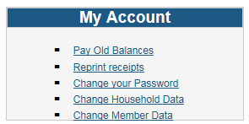
- You should now see a screen similar to the example below. Select the reservation you would like to make a payment towards and choose “Add to Cart”.
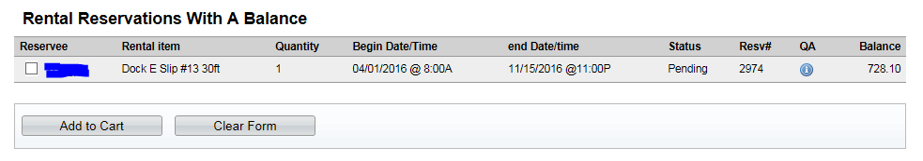

- On the Checkout page you may change the “Amount To Be Paid Today” to the amount of your intended payment. Please remember to pay according to the terms of your installment agreement.
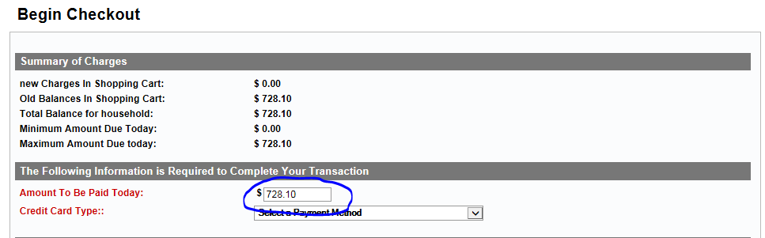
- Continue on to begin the payment authorization process. Use the “View Your Receipt” button to view and/or print a receipt.
- Once you have closed your receipt your transaction is complete and you can select to go back to the “Home Page” or “Log-Out”.
- If you experience difficulties, please call our main number at (920)322-3430.

