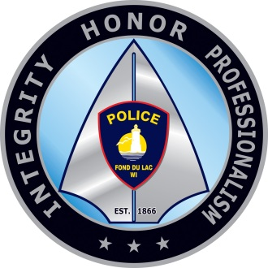**City of Fond du Lac Police Department**

**Passing of K9 Officer Sam**

March 25, 2021

For Immediate Release

Contact Person:

Captain Jason Laridaen

[jlaridaen@fdl.wi.gov](mailto:jlaridaen@fdl.wi.gov)

It is with heavy hearts that we share with our community the passing of K9 Sam. K9 Sam was off duty and became ill overnight and was taken to Bluepearl Pet Hospital (Appleton). Due to a sudden, inoperable medical condition, Sam passed away.

K9 Sam was a 4 ½ year old German Shepherd and had been with the Fond du Lac Police Department for 3 years. K9 Officer Ben Hardgrove and K9 Sam attended training where Sam was trained as dual purpose and was certified in narcotics detection and apprehension/arrests. Sam was also certified through North American Police Work Dog Association (NAPWDA) as well as other specialized training and was part of the SWAT team.

Even when K9 Sam was “off the clock” and before COVID, he enjoyed public events where he could showcase his skills and training.

Officer Hardgrove would like to thank Bluepearl Animal Hospital, Steinig Tal Kennels (Larry Filo), Companion Animal Care and Animal Outfitters for their support throughout K9 Sam’s career.

K9 Sam’s service to the community will always be remembered. At the request of Officer Hardgrove there will be no formal memorial or ceremony.

